Project Design Phase-II
Data Flow Diagram & User Stories

Date | 11 Feb 2026
Team ID | LTVIP2026TMIDS88463
Project Name | FreelanceFinder: Discovering Opportunities, Unlocking Potential
Maximum Mark | 4 Marks

Data Flow Diagrams:
The data flow in FreelanceFinder follows a client–server architecture where users (Clients, Freelancers, and Admin) interact with the React.js frontend, which communicates with the Node.js and Express.js backend through RESTful APIs. User credentials are securely processed using Bcrypt encryption and JWT authentication before being stored in MongoDB. Clients post projects, freelancers submit proposals, and both communicate through a real-time chat system using Socket.io, while the admin oversees and manages system activities. This structured data flow ensures secure access, efficient project handling, and smooth collaboration across the platform.
- React frontend sends requests to Express backend using Axios.
- User authentication is handled using JWT and Bcrypt.
- User data is stored in the Users collection.
- Project details are stored in the Projects collection.
- Freelancer proposals are stored in the Applications collection.
- Chat messages are stored in the Chat collection.
- Admin has access to monitor and manage all collections.
- Real-time communication is enabled using Socket.io.
- MongoDB ensures scalable and efficient data storage.
- Role-based access control manages Client, Freelancer, and Admin permissions.

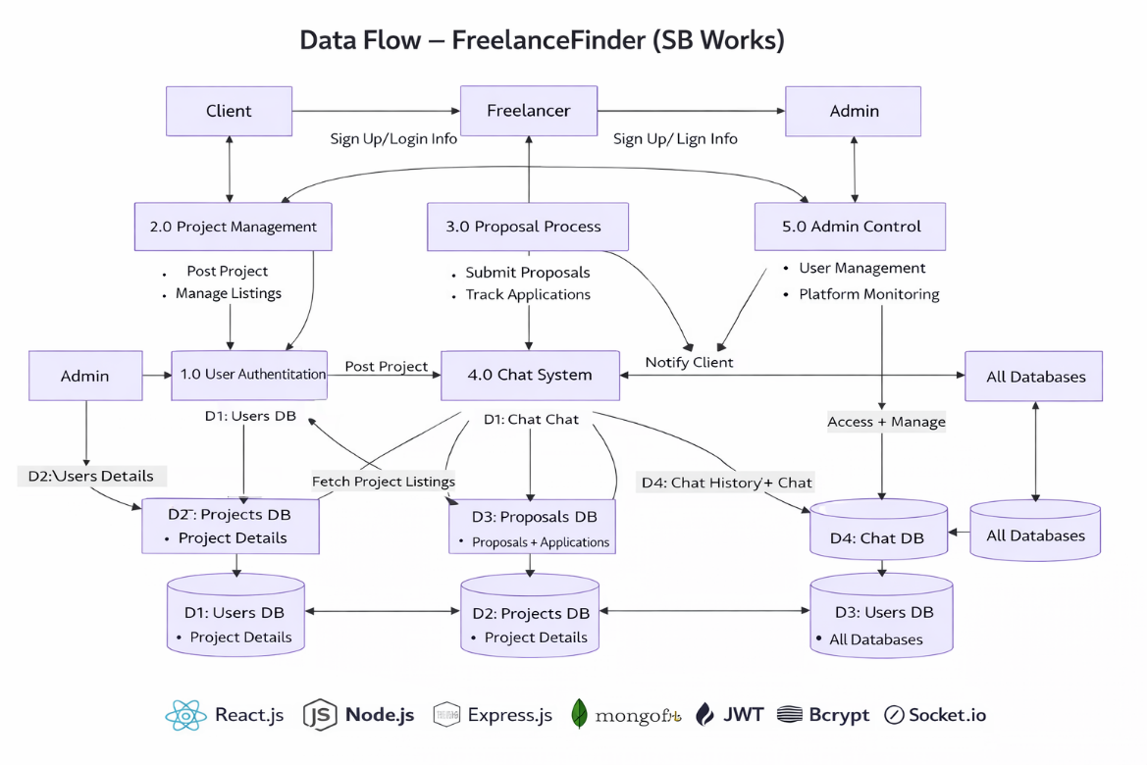

User Stories
- Clients want a secure and simple platform to post projects, review proposals, and manage freelancers efficiently.
- Freelancers want genuine project opportunities, an easy proposal submission process, and a way to build reputation.
- Administrators want complete control over user management, project monitoring, and platform security.

User Type | Functional Requirement (Epic) | User Story Number | User Story / Task | Acceptance criteria | Priority | Release
Freelancer | Registration | USN-1 | As a freelancer, I want to register with name, email, and password so that I can create an account. | User can successfully create an account and receive confirmation. | High | Sprint-1
Freelancer | Login | USN-2 |  | JWT token generated and access granted. | High | Sprint-1
  As a freelancer, I want to log in securely
  using email and password.
Client |  | USN-3 | As a freelancer, I want to log in securely using email and password. | Course saved and visible in course list | High | Sprint-2
  Project Management

